Annex B2. MTP Project Manual of Procedures

Medical Teleparasitology Project

MANUAL OF PROCEDURES

(DRAFT)

University of the Philippines Manila
College of Public Health and National Telehealth Center

Software version | 1.1
Manual version | 1.1
(2015)

Vicente Y. Belizario, Jr., MD, MTM&H
Portia Grace H. Fernandez-Marcelo, MD, MPH
Patrick G. Sylim, MD
Herschel Don D. Go, RMT
Danika Joy D. Bardelosa, RMT

NOTE FROM THE AUTHOR

The Medical Teleparasitology (MTP) System is a web-based application which facilitates the sharing of knowledge on diagnostic parasitology among healthcare professionals over a distance. While this manual, as well as the training that it accompanies, focuses on the software and its meaningful use in submitting image-based referrals as well as monthly aggregate data, it cannot be emphasized enough that the software is the technology component of the project and does not comprise the whole; it is merely the tool that assists the health care professionals in carrying out their work in diagnosing a patient’s problems and providing quality health care. The main thrust of the project is the network of healthcare professionals and the exchange of knowledge among them, with the objective of increasing the national capacity in detecting infections through diagnostic parasitology; therefore, it is important to keep in mind that you, as the healthcare professional, are what drives the project forward. This effort would not be possible without you and we would like to express our deepest appreciation for your continuing support.

ABOUT THIS MANUAL

This manual was constructed as a stand-alone reference material which a health professional can browse to gain the minimal necessary knowledge on operating the Medical Teleparasitology System software. It may serve as a supplement to the training during which it is usually distributed, however, this manual should be able to support basic needs on its own.

This manual is divided into sections, each headed by a business process or a “how-to” question. Business processes included are targeted towards health professionals (i.e. medical technologists and parasitology experts) and will not cover administrative processes. The manual will be updated to accommodate updates to the software.

Should there be any questions that this manual cannot answer, please contact the following numbers:

Neglected Tropical Diseases Study Group (NTDSG), National Institutes of Health
+63(905) 334 3081 or +63(919) 683 7498 (Herschel Don Go, Project Manager)

National Telehealth Center (NTHC), National Institutes of Health
(02) 509 1003 (landline) or +63(917) 505 5923 (Patrick Sylim MD, Project Manager)

INTRODUCTION

The Medical Teleparasitology Project (MTP) was conceived on the notion that increasing the capacity of health care professionals on diagnostic parasitology would contribute to increasing accuracy and precision of diagnosis of parasitic infections nationwide. The methods proposed were twofold: one, to regularly conduct continuous training on diagnostic techniques in parasitology and two, to establish a network through which knowledge can easily be exchanged among professionals.

To facilitate these business processes, an online system was planned as the main tool. The first phase of the project aims to develop a system of consultation wherein medical technologists can remotely inquire about laboratory cases with parasitology experts stationed elsewhere, with transmission of data occurring almost instantaneously. It is also aimed to allow users to enter aggregate data on laboratory diagnosis of parasitic diseases in their facility monthly. A Human Parasite Image Bank has been added as reference material for the convenience of microscopists, as well as a Parasitology Forum wherein microscopists from all over the country can interact with each other by creating topics and responding to other topics. Future project plans would add more functions, such as training modules, parasitology maps, and so on, to further enhance the usability of the tool for capacity building in diagnostic parasitology.

LIST OF ABBREVIATIONS

CAR Cordillera Administrative Region
CDC Centers for Disease Control and Prevention
CHITS Community Health Information Tracking System
CHO City Health Office
DLSU De La Salle University
DOH Department of Health
DOH RO CAR Department of Health Regional Office Cordillera Administrative Region
DOH RO XI Department of Health Regional Office XI
DOP Department of Parasitology
DOST Department of Science and Technology
DP Diagnostic Parasitology
DPCB Disease Prevention and Control Bureau
EPL Emerging Parasitoses Laboratory
ICT Information and Communications Technology
IDO Infectious Disease Office
KMITS Knowledge Management and Information Technology Service
MHO Municipal Health Officer
MT Medical Technologist
MTP Medical Teleparasitology
NIH National Institutes of Health
NTHC National Telehealth Center
NTD Neglected Tropical Diseases
NTDIS Neglected Tropical Diseases Information System
PAMET Philippine Association of Medical Technologists Inc.
PCHRD Philippine Council for Health Research and Development
PGH Philippine General Hospital
PHO Provincial Health Office
RAS Rapid Assessment Survey
RC Referral Center
RD Regional Director
RHU Rural Health Unit
RM Regional Microscopist
UP-CPH University of the Philippines College of Public Health
UPLB University of the Philippines Los Baños
UPM University of the Philippines Manila
UPMREB University of the Philippines Manila Research Ethics Board
WHO World Health Organization

DEFINITION OF TERMS

Computer Terminal | a desktop or laptop that is able to recognize, convert, store, and send digital images captured by the Image Capture Device
Diagnostic Parasitology | refers to the reliable diagnosis of parasitic infections through accurate identification of eggs/larvae/cysts/trophozoites and adult worms in stool or other specimens using standardized techniques, and instruments or equipment in good condition by a well-trained medical technologist/microscopist
Digital Image | all images of microscopic view of the specimens uploaded in the system by the referring medical technologist/microscopist
Expert Pool | a group of diagnostic parasitologists with expertise and noteworthy academic and clinical experience who receives digital images and confers to come up with a confirmatory diagnosis
Hardware | includes the image capture device, computer terminal, and server necessary for the Medical Teleparasitology Project to function
Human Parasite Image Bank | the collection of human parasite images in the Medical Teleparasitology System which can be accessed by the public and can be used for reference, teaching, and training
Image Capture Device | any gadget with camera (e.g. cellular phone, tablet) and/or digital camera with at least 0.8 megapixels that is able to store, transfer and/or send digital images
Local Accession Code  Medical Parasitology | the characters and/or numbers assigned to a specimen mainly used to maintain patient confidentiality  the branch of medical sciences dealing with organisms (parasites) which live temporarily or permanently, concerned primarily with human beings and their medical significance, as well as their importance in human communities.
Medical Teleparasitology Network | a group of medical technologists/microscopists and diagnostic parasitologists who are members of the Medical Teleparasitology System
Medical Teleparasitology Project | an information and communications–based Diagnostic Parasitology that links medical technologists in peripheral laboratories to expert parasitologists for accurate and timely diagnosis of parasitic infections
Medical Teleparasitology System | refers to the information and communications – based application technology consisting of the software and database linked into the Medical Teleparasitology Network
Neglected Tropical Diseases  Referral Center | medically diverse group of infections caused by a variety of pathogens such as viruses, bacteria, protozoans, and helminthes (WHO, 2013  the academic institution (University of the Philippines Manila), that gives the final diagnosis of referred cases through the members of the expert pool
Peripheral laboratory | any general clinical laboratory whether institution-based or free-standing in the regional, provincial, city, municipal, district, or rural health unit located in the regions targeted by the project
Rapid Assessment Survey | survey accomplished by the medical technologists prior to the Diagnostic Parasitology and Medical Teleparasitology training to gather baseline information on diagnostic capacity and endemicity of parasitic infections
Server | a cloud-based storage device that will house all the data collected by the system
Software | an organized operating system or application that will provide the infrastructure for referral of digital images from the peripheral laboratories to the Referral Center, feedback of results to the end-users, and epidemiological mapping of referred and confirmed cases
Telehealth | includes surveillance, health promotion and public health functions. It is broader in definition than telemedicine as it includes computer-assisted telecommunications to support management, surveillance, literature and access to medical knowledge (WHO, 2014)
Telemedicine | the delivery of health care services, where distance is a critical factor, by all health care professionals using information and communication technologies for the exchange of valid information for diagnosis, treatment and prevention of disease and injuries, research and evaluation, and for the continuing education of health care providers, all in the interests of advancing the health of individuals and their communities (WHO, 2010)

I. Background and Rationale of MTP Project

The Philippines is endemic for a number of parasitic infections, many of which are considered as Neglected Tropical Diseases (NTDs) that affect the poor in underserved communities (Belizario et al., 2007; DOH, 2009). There have been previous reports of misdiagnoses of these infectious diseases of poverty, resulting in the delay of treatment of patients and continuing morbidity. Schistosomiasis, for example, was initially misdiagnosed before it was reported in newly-described endemic provinces of Cagayan and Negros Occidental in some years back. A “mystery disease” that resulted in 12 deaths in Monkayo, Compostela Valley where they suspected capillariasis and was confirmed when a local medical technologist sent a stool specimen to the University of the Philippines Manila (UPM). An outbreak of intestinal capillariasis in Compostela Valley was eventually confirmed through an investigation by a group of experts from the Department of Health (DOH) and UPM. In Zamboanga del Norte, there were more than 70 deaths recorded due to misdiagnosis and 4.9% of those examined in a parasitologic survey were confirmed to have capillariasis (Belizario et al., 2010). Another incident was reported in Siargao Island, Surigao del Norte where local health staff misdiagnosed Echinostoma malayanum infection (intestinal fluke) as Fasciola hepatica infection (liver fluke) due to a lack of familiarity with the former (Belizario et al., 2007). Thus, it remains a significant public health concern. Addressing these challenges in diagnosis will need serious efforts in developing the proficiency of laboratory diagnosis, especially in government health facilities where the poor and marginalized sectors are likely to consult (Belizario et al., 2000).

Appropriate medical management of parasitic infections by health professionals largely depends on accurate and timely diagnosis through microscopy and other laboratory techniques. However, most peripheral laboratories in the Philippines, especially those in the local health units, lack the necessary expertise for accurate diagnosis of less common parasitic infections which are emerging or re-emerging. While the expertise is available in certain referral centers like the UPM, health professionals in their respective localities who encounter difficulties in diagnosis of parasitic infections do not have the benefit of a referral system, where these parasitic infections may be misdiagnosed and mismanaged, or left undiagnosed and untreated. The use of an information and communications technology (ICT)-based referral system can provide an opportunity for these local health professionals to be linked to the experts in the referral center without requiring the experts to travel to the countryside. This referral system therefore may result not only in accurate and timely diagnosis but also in improving the diagnostic capacity of laboratory personnel.

The UP College of Public Health–Department of Parasitology (UP-CPH-DOP), National Telehealth Center (NTHC), Department of Health (DOH), and Department of Science and Technology (DOST) collaborated to develop an ICT-based referral system that linked peripheral laboratories with a referral center based in UPM. The UP-CPH-DOP offers intensive training course in Diagnostic Parasitology. It takes a leading role in teaching of research on parasitic diseases and their control, as well as in capacity development in diagnosis of parasitic infections.

In the Philippines, the NTHC, one of the centers of the UPM–NIH, was established to promote the use of ICT in improving healthcare delivery. It manages teleconsults from more than 500 primary doctors in remote areas around the Philippines, linking them to medical experts based at the PGH, Eastern Visayas Regional Medical Center, and Baguio General Hospital and Medical Center. The NTHC has carried out several telemedicine projects including Real Time Community Health Information Tracking System for Maternal and Child Health (rCHITS), teledermatology, telementoring for psychiatric care in post-disaster areas, eLearning for tele-Surgery, SMS- and iPath-based teleconsults for up to 12 clinical domains, and incorporated the use of the RxBox telemedicine device for maternal-neonatal care as well as the detection and management of cardiovascular diseases. It developed and manages the National Telehealth Service Program (NTSP), together with the DOH and DOST (Fernandez-Marcelo, 2014). The teleconsultation and telementoring occur between physicians. These, however, have not specifically addressed parasitic infections through teleparasitology.

The use of ICT in Diagnostic Parasitology through training and reference, diagnostic assistance and continuing education, will ensure accurate and timely diagnosis of parasitic infections. Collaboration among different agencies and institutions will allow the stakeholders to build a network of diagnostic parasitology experts and medical technologists.

Medical Teleparasitology (MTP) is a type of telehealth service which uses ICT for the exchange of information for the diagnosis, treatment, and prevention of disease, research and evaluation, and continuing education of healthcare providers. This project aimed to develop a referral system for cases of parasitic infections that will create a database of the cases referred. The database will map out the distribution of parasitic infections in the two regional pilot sites, namely Cordillera Administrative Region (CAR) and Davao Region.

Utilization of MTP as an innovative technology for diagnosing parasitic infections may prevent cases of misdiagnoses and allow appropriate and correct management of cases of parasitic infections. Using the data from the correctly diagnosed parasitic infection cases and monthly reports from the participating laboratories, a parasitological map of the endemicity and relative frequency can be developed which may be used to update the database of parasitic infections in the participating regions. This will be useful in surveillance, providing quality data, and evidence for advocacy and policy formulation for the control and prevention of parasitic infections (Figure 1).

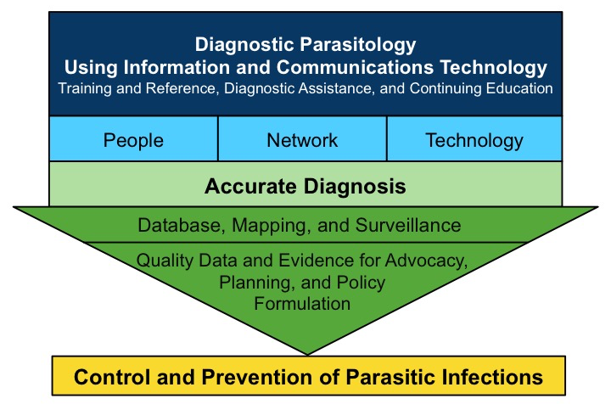
Figure 1. Conceptual framework of the Medical Teleparasitology Project

II. Objectives

The MTP Project aimed to develop and demonstrate the feasibility of a referral system that links medical technologists in peripheral laboratories to an expert pool of diagnostic parasitologists from UPM without necessarily requiring the physical presence of the experts in the said localities. The MTP Project was divided into three phases according to the following objectives:

Phase I: Baseline Assessment of Diagnostic Capacity of Laboratory Staff and Endemicity of Parasitic Infections
  - To describe the diagnostic capacity on parasitic infections of local laboratory personnel in selected regions in the Philippines
  - To describe the endemicity and relative frequency of parasitic infections in selected regions in the Philippines
Phase II: Development of the MTP System (http://mtp.telehealth.ph)
        - To develop an MTP System for the laboratory diagnosis of parasitic infections
  - To develop a teleparasitology database and a distribution map of referred cases of parasitic infections in support of the NTDIS of DOH
Phase III: Implementation of the MTP System
- To demonstrate the feasibility and utility of the MTP System
- To assess improvements in the diagnostic capacity of laboratory personnel participating in the system
- To describe an update on the endemicity and relative frequency of parasitic infections in selected regions in the Philippines using MTP System

III. Components of the MTP Project

- People

Patient

This includes all patients not only with signs and symptoms of a possible parasitic infection but also asymptomatic patients that requires laboratory microscopy for diagnosis, especially on individuals living in underserved and far-flung areas with a known and/or high endemicity of parasitic infections.

Medical Technologist/Microscopist

This refers to licensed medical technologists/microscopists working in a government general clinical laboratory whether institution-based or free standing specifically those assigned in the clinical microscopy section or those routinely performing laboratory microscopy. They must have completed a three-day training course in Diagnostic Parasitology and Medical Teleparasitology conducted by the University of the Philippines Manila Referral Center and should have been issued a certificate of completion.

  - Diagnostic Parasitology Expert Pool

This refers to a group of diagnostic parasitologists with expertise and noteworthy academic and clinical experience who receives digital images from the medical technologist/microscopist and comes up with a confirmatory diagnosis of the referred cases.

The members of the Diagnostic Parasitology expert pool shall have the following responsibilities: 1) provide timely confirmatory diagnosis of referred cases by medical technologists/microscopists in peripheral laboratories; 2) respond to online queries and participate in an online discussion of cases, as necessary; 3) attend scheduled quarterly meetings at the University of the Philippines Manila Referral Center or whenever necessary; and 4) provide suggestions and feedback in improving the Medical Teleparasitology System.

- Application Technology

Hardware

Hardware includes the image capture device, computer terminal, and server necessary for the Medical Teleparasitology System to function.

- Image Capture Device
This refers to any gadget with camera (e.g. cellular phone, tablet) and/or a digital camera with at least 0.8 megapixels that is able to store, transfer and/or send digital images.

- Computer Terminal
This refers to a desktop or a laptop that is able to recognize, convert, store, and send digital images captured by the Image Capture Device.

- Server
This refers to the cloud-based storage device that will house all the data collected by the system.

Software

The software for the Medical Teleparasitology System will provide the infrastructure for referral of digital images from the peripheral laboratories to the Referral Center, feedback of results to the end-users and patients, epidemiological mapping of referred and confirmed cases. A database linked to this program is developed by the National Telehealth Center. NTHC is currently housing the server of the system using http://mtp.telehealth.ph/.

The system involves transmission and storage of confidential patient information which shall occur over the secured network. The network will be adequately encrypted to provide secure station for receiving diagnostic reports. Verifiable digital signatures will be used to maximize security of the program. It ensures reasonable privacy and confidentiality by security measures which include program and user authentication, activity logs, access restriction and archiving.

The system undergoes alpha and beta tests. Alpha test improves the quality of the system by identification of bugs, errors, crashes, missing documents and features of the test engineers or website developers and project staff. Alpha test ensures beta readiness because most identified issues are fixed, added, removed or changed based on the feedback of the initial users. This is done toward the end of the development phase prior to its use in the field.

Beta test on the other hand, is done to improve the quality of the system, to integrate the inputs of the end-users (medical technologists, members of the expert pool, and the administrators) prior to its launching. Beta test ensures further identification of bugs and crashes but is expected that most document features are already complete.

The diagnostic parasitologist, consulting medical technologist and all other persons using the program (administrators, assistants, etc.) shall be adequately authenticated to the system. This authentication involves, at the minimum, a user name and password which will be assigned during registration in the training. All access to the program shall be logged and reviewed on a regular basis by a computer technician. Review will be properly documented. Whenever necessary, the program will authenticate itself unambiguously to all users, for example, using a third party certificate and private key.

The program shall also have an adequate back up and archive mechanism in cases of computer failures or website crash.

- Telecommunication and Network Links

Telecommunication and network links such as the Internet, telephone and mobile phone lines will be used to link peripheral laboratories to the Referral Center. There will be an immediate referral of unknown or unsure specimen findings to the Referral Center. Further, they will also be used to share electronic images from one laboratory to another for discussion and continuing education. The Medical Teleparasitology System will also be utilized in the mapping of parasitic infections using the monthly reports of peripheral laboratories to the Referral Center.

IV. Operations

Project Governance Framework

DOH, PHO, CHO, and RHU Laboratories
Hospital Laboratories
Technical Working Group

(E-Health TWG, DOST-PCHRD, DOH-DCPB, DOH-KMITS, UPM, Independent Experts and Partners)
UP Manila Project Team

UPM-NTD Study Group and Expert Pool, UPM National Telehealth Center
DOH Regional Directors
Provincial Health Officers, Provincial DOH Officers, and Municipal Health Officers
Chiefs of Hospitals (Regional, Provincial, City, Municipal and District)

- Project Team
Expert Pool of Diagnostic Parasitologists*
UP Manila
College of Public Health Department of Parasitology

Project Leader
Diagnostic Parasitology

Dr. Vicente Belizario, Jr.
Research Associate
Mr. Herschel Don D. Go
Research Associate
Dr. Patrick Sylim
Research Assistants
Ms. Danika Joy D. Bardelosa
Program Developer

Mr. Wayne Manuel
Regional Program Coordinator
*Expert Pool
Dr. Vicente Belizario (UPM-CPH)
Dr. Arlene Bertuso (UPM-CPH)
Dr. Elia Cabrera (UP-PGH)
Dr. Florencia Claveria (DLSU)

** Department of Parasitology

Department of Health
Regional Office

Regional Director

Co-Project Leader
(ICT)

Dr. Portia Fernandez-Marcelo

Patient Information Confidentiality and Information Management

All information including electronic referral forms, digital images, and monthly reports, which will be used for mapping of parasitic infections in the Philippines, submitted by the medical technologists through the Medical Teleparasitology System (http://mtp.telehealth.ph) will be archived at the Referral Center. The Diagnostic Parasitologists, consulting medical technologists and all the users registered shall be adequately authenticated to each other and to the system. The users will be authenticated as they are provided with a username, and password and identifier such as roles in the system, which will be assigned during the training. All access to the system shall be logged and reviewed on a regular basis by a computer technician. Review will be properly documented.

Confidentiality and security of patient information shall be ensured and patient privacy shall be protected. The NTHC shall exert adequate measures to secure its database for the Medical Teleparasitology Project. It shall employ available and necessary physical, electronic, procedural and legal policies to prevent any theft, leakage, corruption or loss of electronic data gathered from the MTP System. All information from the interaction between the referring medical technologist and his/her patient is considered confidential information, including Teleparasitology referrals.

Only registered medical technologists who have undergone the Training on Diagnostic Parasitology and Medical Teleparasitology have the privilege to create, close, delete and cancel referral and monthly report forms in the Medical Teleparasitology System. The members of the Expert Pool shall have access to all the referrals and be entitled to provide diagnosis to the case of the referring medical technologist. Any visitor of the website has access to the Human Parasite Image Bank. The administrator shall be responsible for monitoring and maintenance of the system, and has complete access to the system.

All information related to and resulting from the use of telemedicine/teleparasitology through the Medical Teleparasitology System shall be classified as a medical record and shall be treated appropriately as such. The full name and other personal identifiable information of patient being referred/consulted through teleparasitology between the referring medical technologist and the Diagnostic Parasitologist shall be kept to the minimum to ensure patient privacy. Only pertinent identifiers- such as patient initials, age, sex, barangay as well as relevant clinical information (chief conplaint) shall be relayed to the Diagnostic Parasitologist, to aid the Expert on his/her diagnosis.

Records of each end of every teleparasitology consultation in its entirely shall be kept and archived by the NTHC. All data shall be considered as property of the patient, the referring medical technologist, the NTHC and DOST. These records can be utilized/analyzed for program implementation review, cost-benefit analysis and other public health social researchers and overall public health program management, provided that specific patient information that would lead to patient identification is not included or written permission from patients is secured.

D. Collaborating Agencies

            - Department of Science and Technology-Philippine Council for Health Research and Development (DOST-PCHRD)

The Department of Science and Technology-Philippine Council for Health Research and Development (DOST-PCHRD) will be funding the implementation of the project through the Grants-in-Aid (GIA) Funds of the DOST. It will provide technical assistance relevant to the achievement of the project objectives and will provide other forms of assistance to the project in coordination with other government agencies in matters requiring their attention or cooperation in so far as these are relevant to the project and within the capability of the PCHRD. It will also provide a server that will house the Medical Teleparasitology System.

            - Department of Health (DOH)

The Department of Health Central and Regional Offices will serve as co-implementers of the Medical Teleparasitology Project. Two regions namely the Cordillera Administrative Region (CAR) and Region XI have been selected to be pilot sites of this project which can potentially become the basis for a nationwide implementation through a national program. The Regional Director will serve as the counterpart of the Project Leader and will assist in the implementation of activities related to the project. Memorandum of Understanding will be signed to formalize the collaboration.

For the first year of implementation, the DOH-RO will help out in inviting medical technologists/microscopists from local health units for training. The DOH-RO will also facilitate the administration of the Rapid Assessment Survey (RAS) forms which will be used to screen prospective training participants. For the succeeding years, the DOH-RO may assume the responsibility of the implementation of the project as agreed upon by both parties. The University of the Philippines Manila will provide technical assistance related to training.

            - Academic Institutions

Academic institutions in the selected regions will also be invited to participate in the Medical Teleparasitology Project as partners. The academic institutions namely Davao Medical School Foundation, Inc. (DMSF Inc.) in Davao City and Saint Louis University (SLU) in Baguio City will be the venue for the three-day training course on Diagnostic Parasitology and Medical Teleparasitology with the intent of developing it as possible regional training sites for the project. In the future, the academic institution may also serve as a possible base of a local pool of experts in Diagnostic Parasitology linked with the Referral Center.

            - Local PAMET Chapter

The Philippine Association of Medical Technologists, Inc. (PAMET, Inc.) Local Chapter will help out in information dissemination and encourage participation of local medical technologists in the system. In the future, they may also co-sponsor the Diagnostic Parasitology and Medical Teleparasitology training and offer it alongside the other trainings that they provide for medical technologists as part of continuing education.

            - Future Collaboration

Future collaboration shall be explored with other institutions or organizations such as Philippine Association of Schools of Medical Technology (PASMETH), Philippine Council for Quality Assurance in Clinical Laboratories (PCQACL), and Philippine Society of Parasitology, Inc. (PSP).

V. Capacity Building

Selection of Participating Laboratory Staff

The effectiveness and accuracy of Medical Teleparasitology depends critically on the skill and judgment of the medical technologists. A Rapid Assessment Survey (RAS) will be conducted in collaboration with the two DOH Regional Offices. Submission of the RAS forms is a prerequisite for inclusion in the training. The RAS forms will be deployed to all of the provinces of the two pilot regions to be accomplished by local medical technologists. The forms will also be made available electronically to facilitate faster distribution and collection. The accomplished RAS forms noted by their Provincial Health Officer (PHO) or City Health Officer (CHO) or Municipal Health Officer (MHO) will be sent back to the DOH Regional Offices to be noted by the Regional Director then to UPM for screening. The list of participants for the training will be finalized by UPM and will be forwarded to the Regional Office with the drafted letter of invitation for the training.

Selected medical technologists from the peripheral laboratories will undergo a three-day training course on Diagnostic Parasitology and an orientation on Medical Teleparasitology to be conducted by UPM-CPH and NTHC in collaboration with DOH-RO and the other mentioned agencies. The participants who satisfactorily completed the training will be included in the Medical Teleparasitology Network.

Training Module Design

The training will consist of a three-day course on Diagnostic Parasitology and Medical Teleparasitology. This training aims to review the procedures in Diagnostic Parasitology and orient on how the Medical Teleparasitology System works. The specific objectives of the training are:

- To describe the epidemiology of intestinal parasitic infections in the Philippines
- To describe measures for control and prevention of intestinal parasitic infections
- To describe and perform laboratory procedures for diagnosis of intestinal parasites in stool specimens
- To identify intestinal parasites in stool specimens
- To describe quality assurance in diagnosis of intestinal parasitic infections
- To describe Medical Teleparasitology System and its application to Diagnostic Parasitology
- To demonstrate the utilization of Medical Teleparasitology System
The training will include lectures on epidemiology, control and prevention of intestinal parasitic infections in the Philippines, laboratory diagnosis of intestinal parasites in stool specimens, quality assurance in diagnosis of intestinal parasitic infections in the form of didactics, laboratory sessions, theoretical and practical examinations. There will also be lectures on Telemedicine and Teleparasitology, ethical considerations in eHealth and Telemedicine and a simulation of the Medical Teleparasitology System using the actual website.

Continuing Education

Aside from referring unknown specimen to the Referral Center, the trained medical technologists in the peripheral laboratories will send monthly report of known parasitic infections they have examined. All the images from these peripheral laboratories and from other joining organizations or academic institutions will be deposited in a database or the Image Bank. These images may be used by participating organizations or institutions as reference. Monthly case studies with diagnostic quizzes will be done using the materials obtained in the Image Bank for continuing education of those who are part of the network.

VI. The Medical Teleparasitology System

THE BASICS

What do I need before using the Medical Teleparasitology (MTP) System?

Version 1.0 of the application has two main operational functions: online image-based referral, and submission of monthly reports. Therefore, before you access the system, you should have either a case (as well as images from microscopic visualization of parasites for that case), or a set of aggregate data for submission. Version 1.1 added the Human Parasite Image Bank and the Parasitology Forums, which are for reference and networking, respectively.

Capturing images of specimens. Studies have evidence that acceptable resolutions for adequate sensitivity and specificity are equal to or greater than 0.8 megapixels. Images of microscopic samples may be taken with any camera with a minimum resolution not lower than 0.8 megapixels, and done by holding the image capture device steadily (preferably stabilized by a finger supporting the device on the eyepiece).

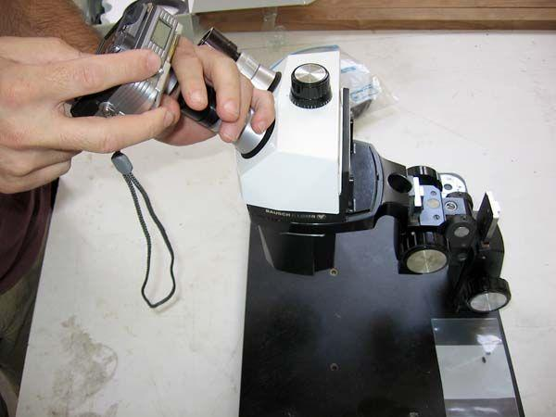
Figure 1. Manually taking a picture of a microscope slide field using a digital camera as an image capture device. Note how the camera is stabilized with the left hand - the technique may vary from person to person depending on what is most comfortable.

A mechanism to electronically transfer the image files should be available (like a camera-to-USB cable or a USB drive, depending on the image capture device) if the image capture device itself is incapable of connecting to the internet in some way. If the device has a web browser and a stable internet connection, then the images can be sent straight from the device.

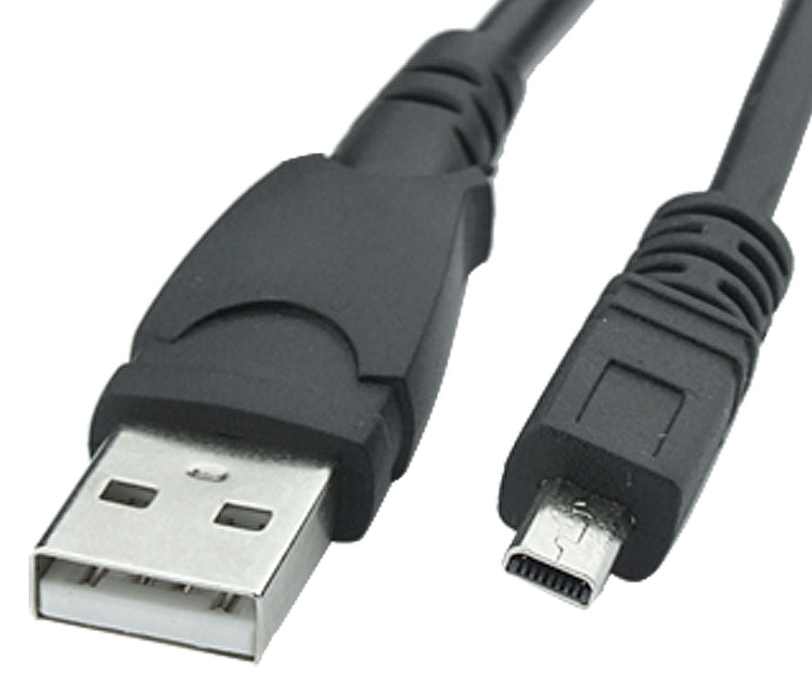
Figure 2. One of the possible configurations of ports for a camera-to-USB cable. This may vary from device to device, but usually comes with the device upon purchase from the store.

Copying the images from the image-capture device (optional). Digital cameras and mobile devices equipped with cameras that do not have a mobile data subscription or an internet connection may require transferring of the image files to a device such as a laptop or a desktop computer with an internet connection before accessing the MTP system. The transferring process varies for each device, but the most basic way is to do the following:

- Click on the Start button (usually on the lower-left part of the screen on Windows machines) and click on the My Computer link on the Start Menu.

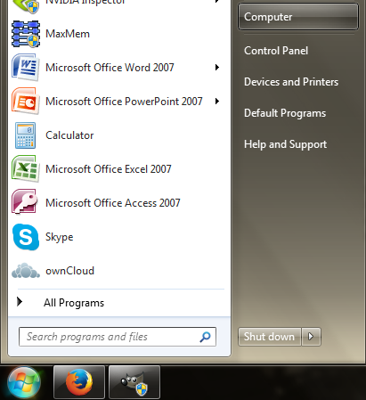
Figure 3. Start Menu, with ‘My Computer’ highlighted.

- On the next screen, double-click on the icon of the connected image capture device (an alternative would be to right-click the icon and select “Open” from the menu that appears).
- Search the files in the device.
- Highlight all the files for transfer. You can either hold the Control key (Ctrl) and press the C button while the files are highlighted, or right-click the files and select “Copy” on the menu that appears.

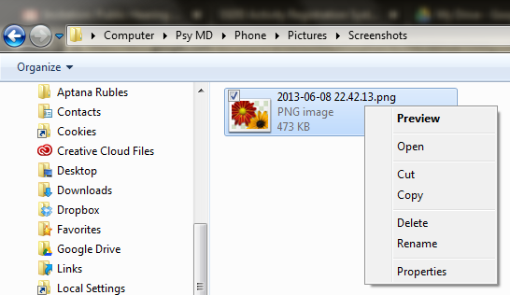
Figure 4. Folder with an image file opened, with the image file highlighted, and the Menu with “Copy” shown. In this example, the image capture device is “Psy MD” (steps 2-4).

- Open the destination folder of your choosing and either hold Ctrl and press the V button, or right-click in the white space and click “Paste” on the menu that appears.

GOOD PRACTICE: Some may consider renaming the files based on a naming format (such as patient initials + date) a good practice of keeping better track of image files, instead of the series of numbers that a standard digital camera may use (on default settings).

From here on out, business processes will involve the actual MTP system. The succeeding content will deal with one business process per section.

BUSINESS PROCESSES IN OPERATING THE MTP SYSTEM

How do I open my web browser?
The web browser you use to access the MTP website is your preference (or whichever you like the most or with which you are most comfortable). It is usually accessible through the Desktop (appears as an icon) or the Programs folder in the Start Menu.

You can open your web browser by clicking on its icon twice (if on the Desktop) or clicking its name once (if in the Programs folder).

How do I navigate from my browser homepage to the MTP website?
When you open your web browser, it usually displays a homepage that is not the MTP website by default. While you can choose to set the MTP website as your default homepage, it will not be covered in this manual. Instead:

- Click on the address bar of your browser and erase its contents.
- Typing in mtp.telehealth.ph will direct you to the homepage of the MTP website.
The homepage itself is open to the public and does not require login.

How do I navigate the MTP homepage?
The MTP homepage has several points of interaction. See below:

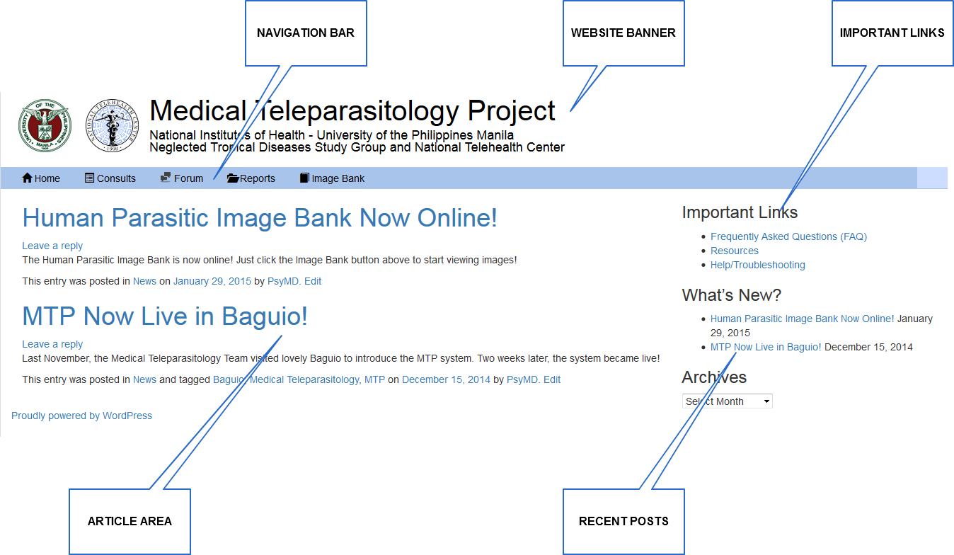
Figure 5. MTP website homepage. This can be accessed by anyone, regardless of login status.

The homepage has the following components:

Website Banner | Top area that contains the project name and the institutes involved in the development of the MTP system, as well as their respective logos.
Navigation Bar | Horizontal bar that contains links that allow the user to go access the different functions of the MTP system.
Important Links | List of links that allow the user to go to other publicly accessible pages of the website:  Frequently Asked Questions (FAQs). List of MTP system-related questions frequently asked by the users, answered by the administrators and/or the developers.  Resources. Page containing download links to documents, manuals and powerpoint presentations related to Parasitology and the MTP system.  Help/Troubleshooting. Form dedicated for issues that users may have about the website or the project in general. The information entered in this form is submitted to the Neglected Tropical Diseases Study Group (NTDSG).
Article Area | Area which displays pages depending on links clicked or tapped by the user. By default, the latest news and articles are displayed.
Recent Posts | List of the most recent articles posted on the MTP website.

How do I register for MTP?
Clicking on any of the links on the navigation bar (except Home) will direct you to a login window. It should look something like the one shown below:

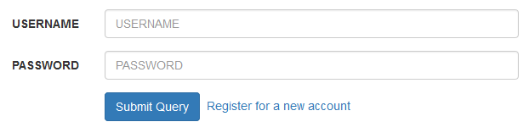
Figure 6. Login window of the MTP website. The website directs you to this window should you click on links that require authentication of identity for access.

- Click on the link “Register for a new account”.
- Fill up the necessary information. All fields with (*) are required.
- Click “Register”.
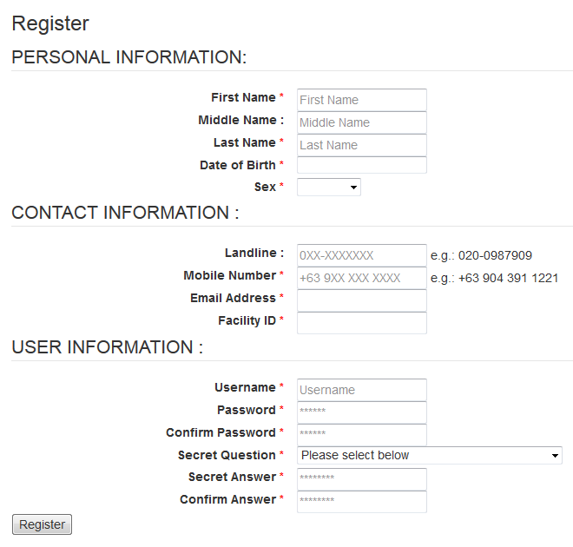
Figure 7. Registration form for the MTP system. Upon clicking Register, the application form will be pending approval from the administrators. This is to ensure that users of the system are known health professionals.

The user application will then be queued for approval from the system administrators. Approval shall be given once the identity of the user has been verified. Once the application has been approved, the user shall be informed that they can now login and use the system.

First Name | First or given name.
Middle Name | Middle name, or mother’s maiden last name.
Last Name | Last or family name.
Date of Birth | Date of birth. Format: <MM/DD/YYYY>
Sex | Sex. This is a dropdown menu.
Landline | Landline number. Format: <3-digit area code><hyphen><7-digit phone number>
Mobile Number | Mobile number. Format: +<2-digit country code><space><3-digit telco code><space><first three digits of mobile number><space><last 4 digits of mobile number>
Email Address | Email address.
Facility Name | Facility name. This field is predictive, which means you can type three letters or above and it will try to predict what you want to enter. You may continue typing to narrow down the choices, or choose the correct answer from the list of choices.
Username | The username you want to have. You will be able to use this after your application is approved. This can be whatever you want.
Password | The password you want to have. You will be able to use this after your application is approved. This can be whatever you want, as long as you remember it.
Confirm Password | Retype your password here.
Secret Question | A secret question for when you forget your password and the system has to confirm your identity to reset your password. This is a dropdown menu.
Secret Answer | Answer to the secret question. This can be whatever you want, as long as you remember it.
Confirm Answer | Retype your secret answer here.

How do I log in the MTP system?
Recall Figure 6 and the login window.
- Click on the box to the right of USERNAME and type in your username.
- Click on the box to the right of PASSWORD and type in your password.
- Click “Submit Query”. Alternatively, you can just press the ENTER (↵) key after typing in your password in the PASSWORD box.

You shall now be taken to the “Pending Consults” page by default.

How do I create a consult?
- Click on the + NEW CONSULT button on the left of the MTP website.

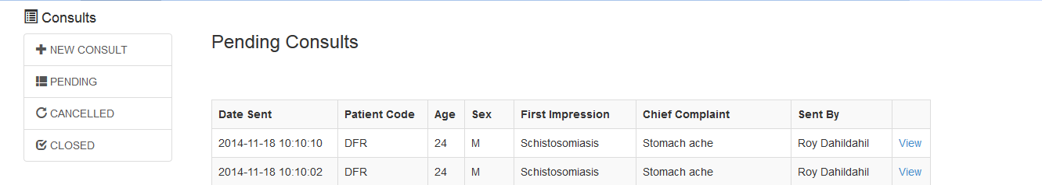
Figure 8. Pending Consults page, showing the +New Consult button on the left portion of the website. Click this to open the New Consult Form.

- On the New Consult Form, fill out the data necessary:
  - Patient Code. This pertains to patient initials. Please do not enter the patient name here. The patient’s name is sensitive information.
  - Age. Patient’s age.
  - Sex. Patient’s sex. This is a dropdown menu.
  - Barangay. Barangay where the patient resides. Typing more than 3 letters will trigger the this field to try to predict what you are trying to input (see Figure 9). This may take a few seconds. When the list appears, you may click the appropriate choice if it is listed, or continue typing to narrow down the list. We recommend keying in a barangay present in the list since the source is the Philippine Standard Geographic Codes or PSGC. Should you encounter any issues with this field, please contact the administrators.
  - Chief Complaint. The chief complaint of the patient during the consult.
  - Initial Lab Diagnosis. Diagnosis written in the format of how the laboratory writes its diagnoses. This could also be the name of the suspected organism or organism-related disease (e.g. filariasis).
  - Clinical History/Message to Pathologists (Optional). Optional area for placing a short clinical history, and/or questions for the pathologists that will view your consult. Feel free to type your other queries here.

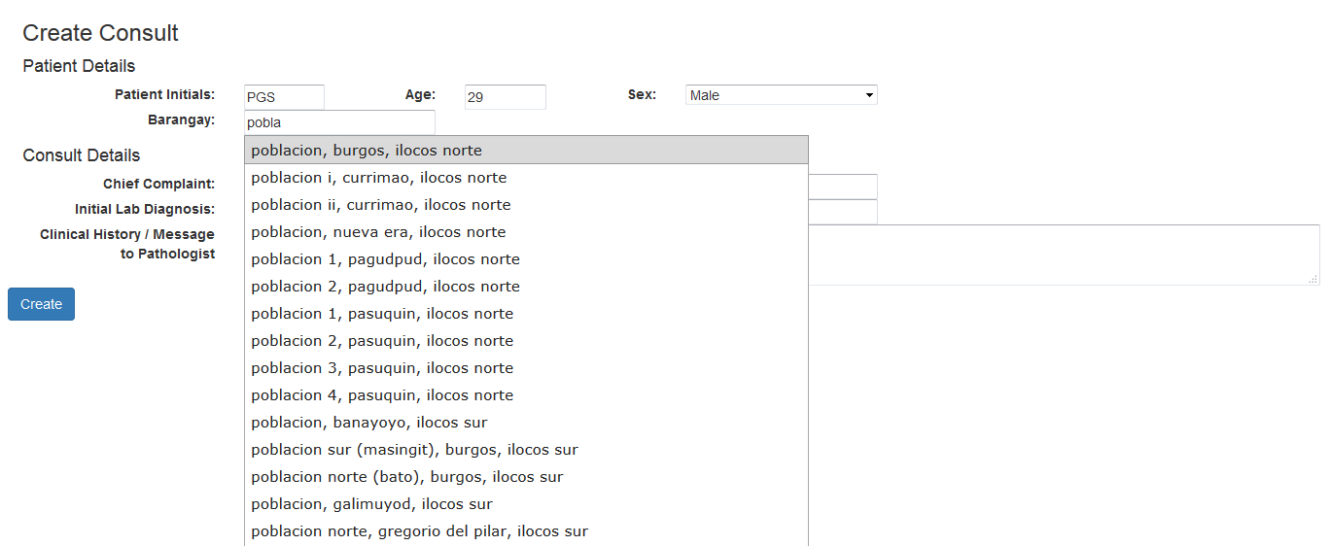
Figure 9. Create Consult Form, with the Barangay predictive drop-down menu expanded.

- Once the data are all in, click “Create”. This will save the information on the consult and allow you to add specimen to the consult (see next section). As a precaution, please recheck that the data you entered matches the data you want to submit. If there are errors on your submission, you can edit, cancel or close the consult (see appropriate sections).

How do I add a specimen to a consult?
Once a consult is created, you may start adding specimen to as attachments. The specimen panel can be found to the right side of a created consult.

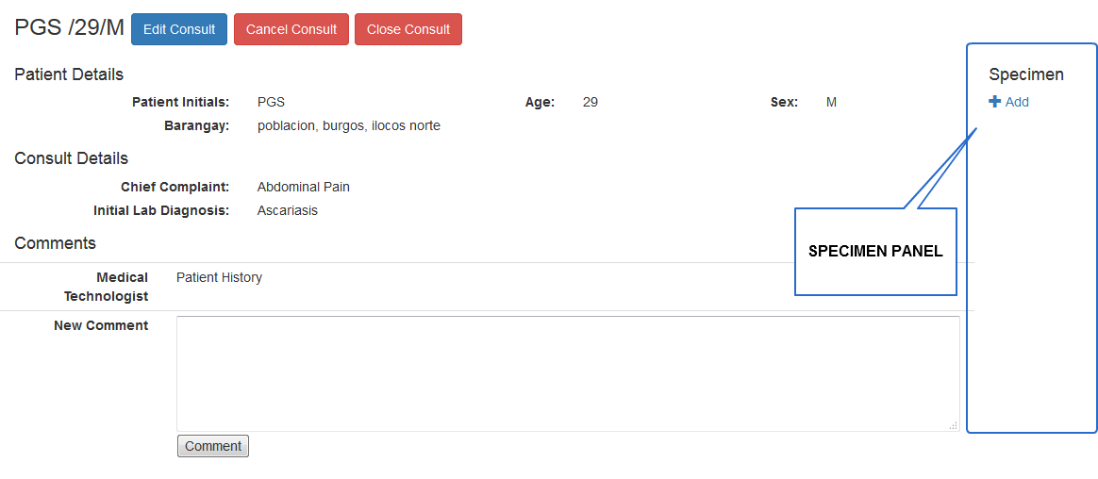
Figure 10. A consult after it has been created. Note the following: Specimen panel (right side), Comments panel (bottom), Cancel and Close Consult Buttons (top, beside the consult ID).

- Click +Add button on the specimen panel (see above). This should bring up the Add Specimen Form. Fill out the form with data from your case.
The Type of Specimen field is always required. As you fill up the form in order, the form may updates itself.

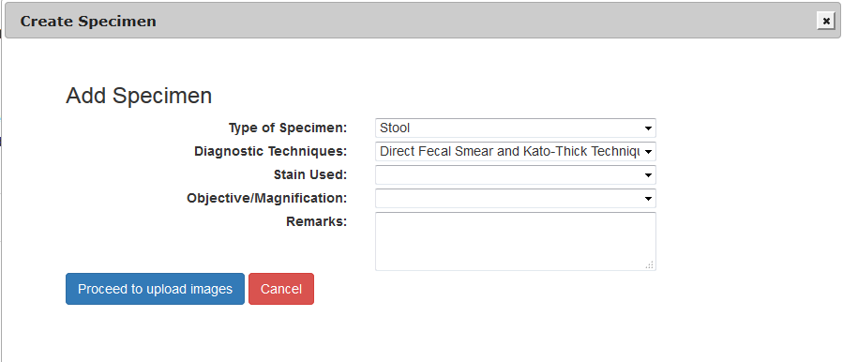
Figure 11. Add New Specimen Form. The Type of Specimen field is required. The form adjusts as you enter data.

- Once you have entered all desired data, click the “Proceed to Upload Images” button. Otherwise, you may click the “Cancel” button. This saves the data entered thus far and will open up a panel below - the Attachments panel.

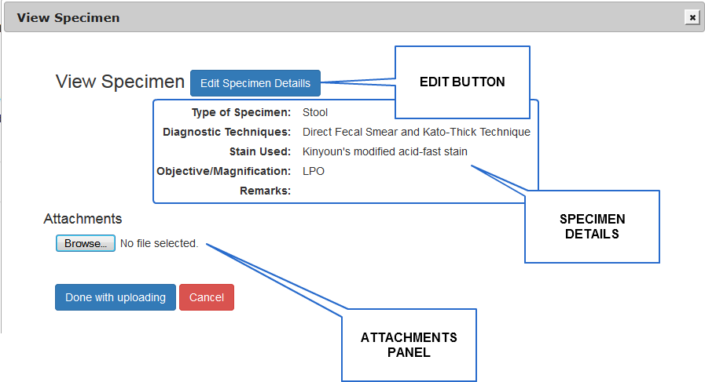
Figure 12. Specimen form after details entered and “Proceed to Upload Images” button has been clicked or tapped. The edit button allows you to edit the data on specimen details, and the attachments panel is where the images will be uploaded. “No file selected” means that there is no file currently in the process of uploading; if there is, the file name and the upload progress (in percent %) will be displayed in this area). The “Done with Uploading” button closes the window.

When the specimen details are saved, you can exit and enter the specimen window at any time to add or remove attachments. It is possible to exit the window without attaching an image, as long as the data is saved. However, it is recommended to have at least one attached image for the experts to work on.

- Click the Browse button. This will open up a dialog box wherein you can navigate your device’s folders and choose an image to upload.

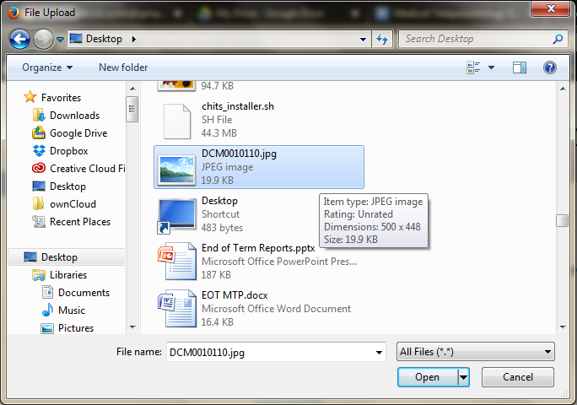
Figure 13. Upload dialog box. To make tracking files easier, you may use a personal system for renaming images.

- If you want to remove an image from the Attachments Panel, click on the Close (X) button on the upper-right corner of the image (see below).

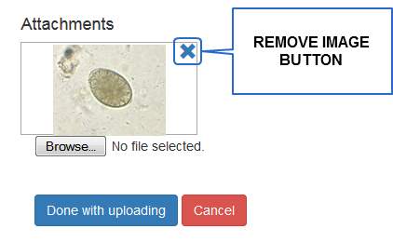
Figure 14. Remove Image Button. Click or tap on this button to remove an image from the attachments panel. The system will ask you to confirm image removal before proceeding.

- Once all relevant images have been uploaded, press the “Done with Uploading” button. You make click the link to this specimen to attach or remove images in the future, as needed.

How do I edit, cancel or close a consult?

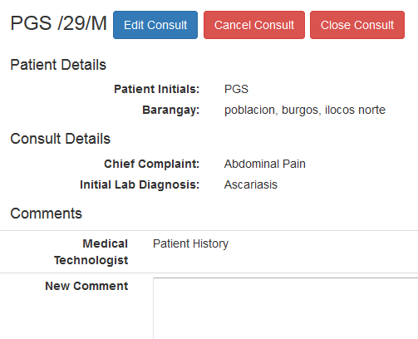
Figure 14. Consult page. Note the three buttons beside the consult name: Edit, Cancel and Close Consult buttons.

Once you save the details of a consult, you have the option to edit the data you submitted, to cancel the consult or to close the consult. Please note the difference between cancelling and closing a consult:
Cancelling a consult will put it in the Cancelled Consults list. This option is reserved for cases where you made a mistake, or just changed your mind about making a consult. You will be asked for the reason for cancelling the consult.
Closing a consult will put it in the Closed Consults list. This option is reserved for cases where your question has been sufficiently answered and you are satisfied with the resolution of your issue, and thus decide to close the consult for archiving. You will be asked for the final diagnosis (which is the diagnosis you will write on the laboratory result form), as well as some feedback on the system.

How do I comment on my consult and view comments on my consult?
Recall Figure 10, which shows the consult page. At the bottom, there is a Comments Panel, which updates when a comment is submitted by a parasitologist or a medical technologist and the page is reloaded or refreshed. This box is always enabled as soon as the consult data is saved; a comment may be added at any time.

- Click on the Comment box and type a comment.
- Click the Comment button. Your comment will then be added to the thread. Use this function to converse with the parasitologists.

How do I create a monthly report?
The system comes with a function to submit reports on the aggregates of cases for parasitic organisms seen in the laboratory setting.

- Click on the Reports link. You will be directed to a list of previously submitted reports (incidentally, this is how you view your reports; alternatively, you can click on Archive). If you have not submitted reports, this will be an empty page with headers for a table.
- Click on +New Report button. You will be directed to a table with the years as headers and months as rows. A green checkmark will mark those month-years with accomplished reports. A blue [+] button will mark those without. Click the [+] button for the appropriate month-year to begin making a report.
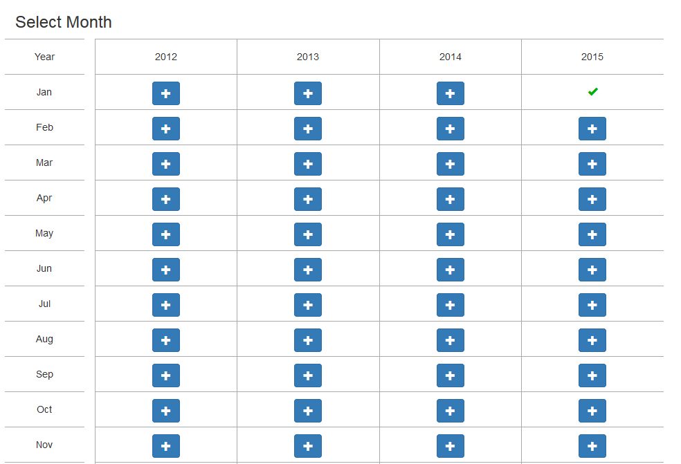
Figure 16. Table of Reports. Note the green checkmark that denotes that a report has been submitted for January 2015. Blue [+] buttons mark month-years without reports.

- Enter the data required. Default is zero (0) for each field which means you have not encountered a case for that organism for that month.

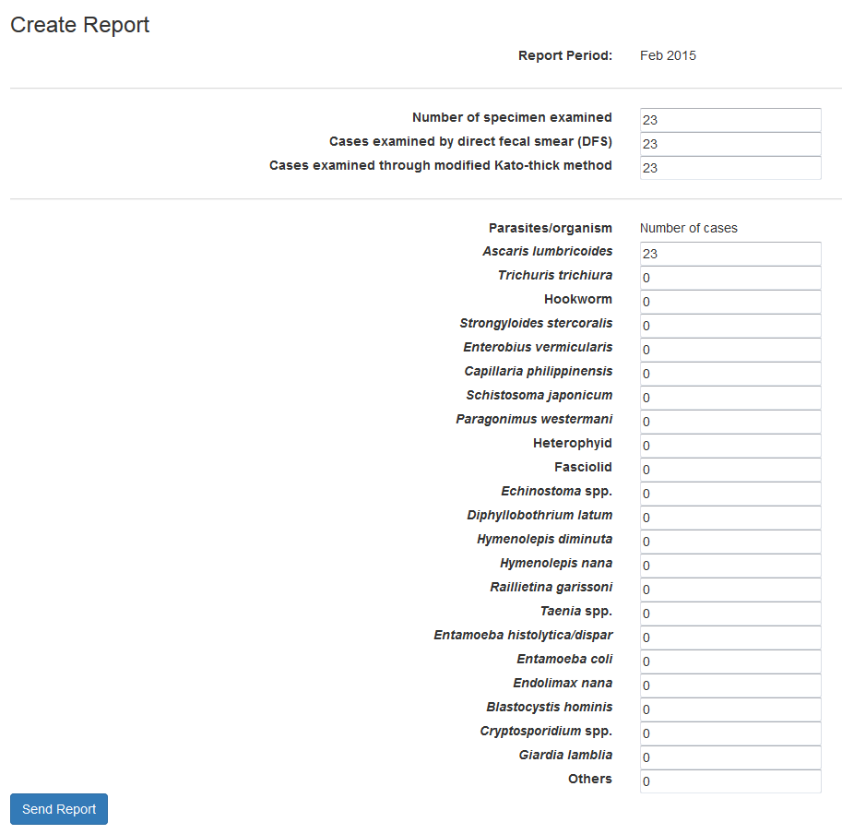
Figure 17. A report with data entered. Please note that blanks are not allowed in the report forms. If you have not encountered any cases of the organism in question, leave the value at zero (0).

- After entering all relevant data, click on Send button. The application then gives you a preview of the submitted data before proceeding. Please note that all fields are required (no blanks).

GOOD PRACTICE: It is recommended that you review all data that you enter in the fields before submitting them. Reports cannot be edited once submitted. The system checks for submitted reports per facility, which means if someone from your facility, other than you, submitted a report for that month-year, you will see a green checkmark.

How do I view the monthly reports I have submitted?
While you are in the Reports section of the MTP system, click the Archives button on the left-hand side. This will take you to the list of reports that you have submitted.

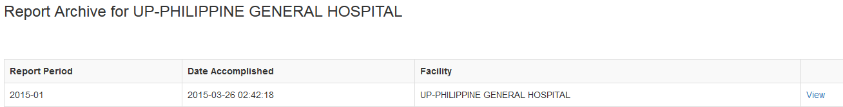
Figure 18. Archive List. All reports submitted for your facility are listed here.

Clicking on the View link to the right will let you view the details of the report. Please note that any and all reports submitted cannot be edited. For issues please contact the system administrators.

How do I access the Human Parasite Image Bank?

The Human Parasite Image Bank is an image repository implemented for the reference of MTP system users. It contains sample images of organisms commonly seen in the laboratory setting as well as the details in viewing the images, such as stain used, magnification, and so on.

- To access this section, you must be logged in. Click the Image Bank link in the navigation bar. You will see a table of organism groups.

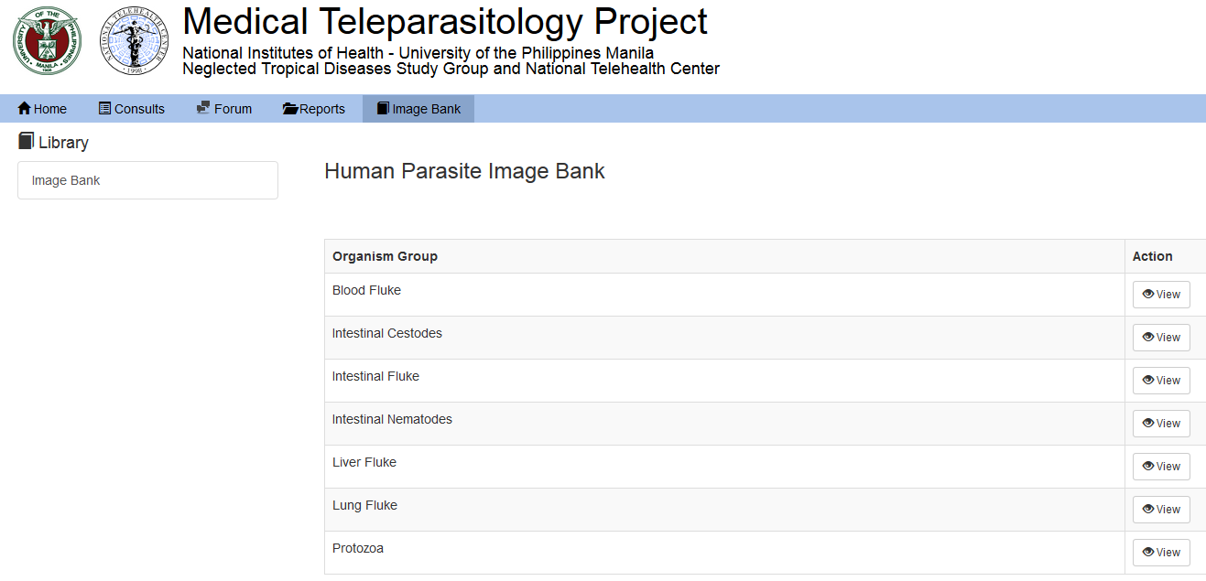

Figure 19. Human Parasite Image Bank, showing the table of organism groups.

This table has a branching structure: organism group > organism > specimen.

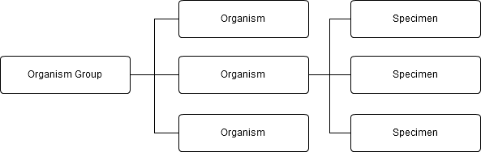
Figure 20. File structure of the Human Parasite Image Bank.

- Click on the buttons at the right side of the table to go further into the image bank hierarchy, until you find your desired images.

How do I access the Parasitology Forum?
The Parasitology Forum is an independent forum nested within the MTP system, implemented to give all health professionals and users an environment wherein they are free to discuss with colleagues relevant topics deemed unfit for the Consults section.

Upon going to the MTP website, you can access the forums by clicking on the Forum link on the navigation bar. You will be taken to the Parasitology Forum login window.

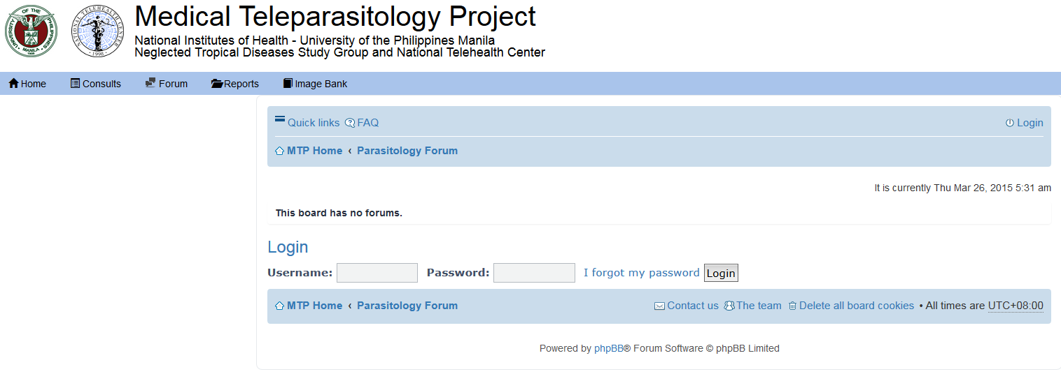
Figure 21. Parasitology Forum login window. While you don’t need to be logged into the MTP system to use it, you need to be registered to the MTP system. Please see the section How do I register for MTP? for further details.

You can log in the Parasitology Forums without logging into the main MTP system. However, you still need to be registered to the MTP system to do so. Please see the section How do I register for MTP? for information on how to register to the MTP system.

It is important to note that because the Parasitology Forum is independent of the MTP system, you have to log out of the forum separately after your session.

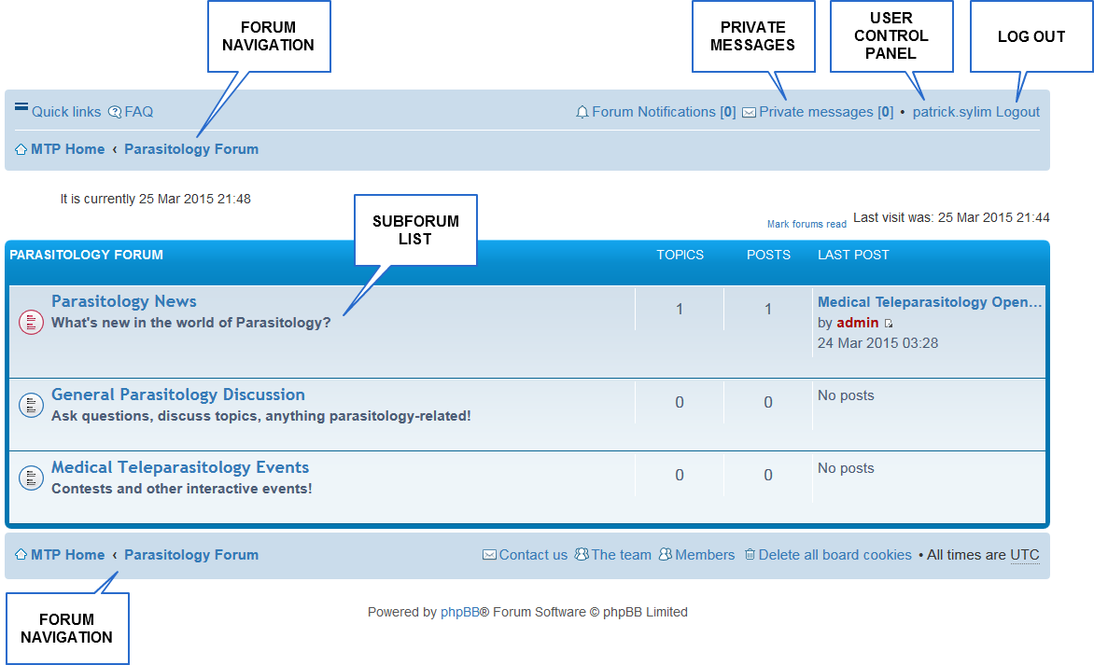
Figure 22. Parasitology Forum for a user who is logged in. It functions in the same way as any conventional forum.

Forum Navigation | Also called breadcrumbs because it is basically a trail record of your path through the forum hierarchy. Each section in this sequence is clickable, and will direct you to the corresponding level of the forums. In the instance of Figure 22, clicking on MTP Home will direct you back to the MTP website homepage.
Private Messages Link | Clicking this will direct you to the private messaging section. You can send private messages to other registered users in the forum. It has an inbox, an outbox, a draft folder, a sent folder, and folder settings.
User Control Panel Link | Clicking this will direct you to a page where you can edit your profile and user group. We do not recommend editing user groups. Your access to these forums depend on these settings.
Log out Link | Clicking this will log you out of the forums. Please note that this does not automatically log you out of the MTP system itself.
Subforum List | This lists subforums within the Parasitology Forum. Feel free to explore them, respond to topics and create topics yourself.

Creating a Forum Topic
Click on a subforum related to the topic you have in mind. Look for the New Topic* button.

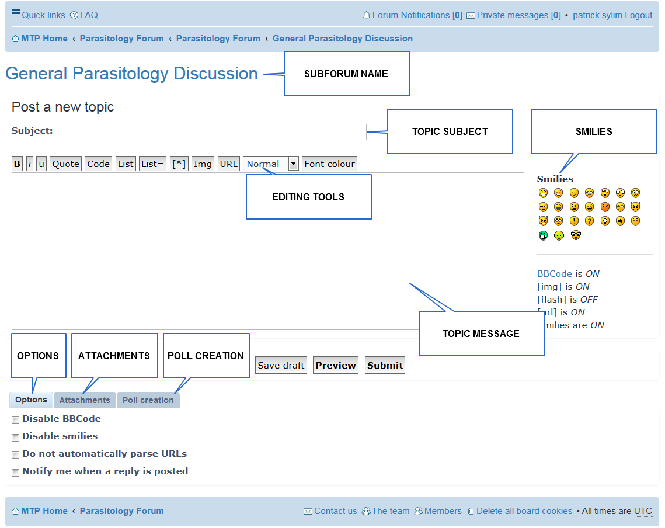
Figure 23. Create Forum Topic screen.

Subforum Name | This area displays the parent of the topic. In the case of Figure 23, the parent is the subforum General Parasitology Discussion.
Topic Subject | This contains the subject. This appears as the link in the topic list of the subforum once the topic is created.
Editing Tools | Text editing tools for the topic message.
Smilies | A catalog of possible smilies. Clicking one will insert it into the topic message where the cursor is located.
Topic Message | Body of text for the message that appears with the topic. It also appears as text in the subforum topic list.
Options | Options for the entire topic and responses to it. Changing this is unnecessary.
Attachments | Clicking on this tab will allow you to attach files to your topic.
Poll Creation | Clicking on this tab will allow you to make a poll in which responders can vote.
Save Draft Button | Clicking this will save your topic in the database, but will not necessarily publish it (remains hidden to other users).
Preview Button | Clicking on this will allow you to preview your message along with any embedded images and media before publishing your topic. We recommend using this button always as a practice. This also allows you to view attachments and their status, as well as delete specific attachments.
Submit Button | Clicking on this will allow you to submit your topic immediately for publishing.

Deleting a Topic
Once a topic is created, only the user who created the topic or the administrators can delete it. To do so, first access your topic.

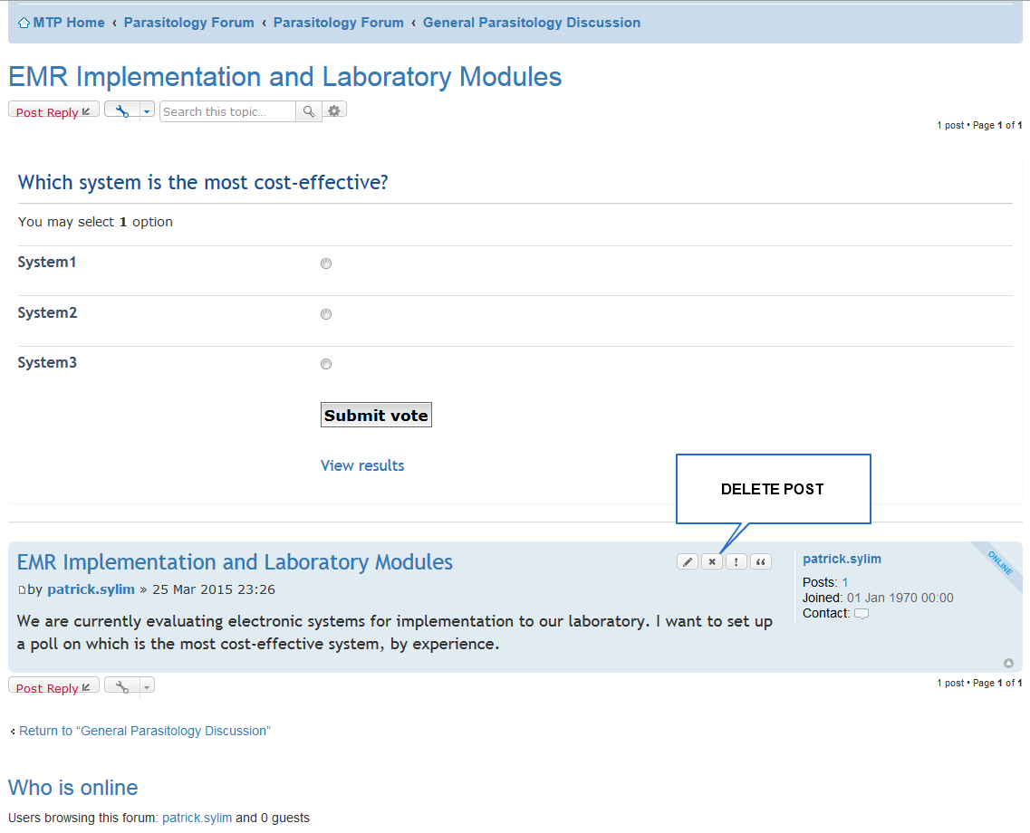
Figure 24. Forum Topic with the Delete Post button pointed out.

Note: The forum treats polls as “Stickies”, meaning polls always stay at the top of the forum topic. Hence, the topic message, as well as the edit, delete, report and quote post buttons, are found below polls, as shown in Figure 24. Clicking the delete post button will allow the user to delete a created topic.

Replying to a topic
To reply to a topic, first access the topic then look for the Post Reply button.

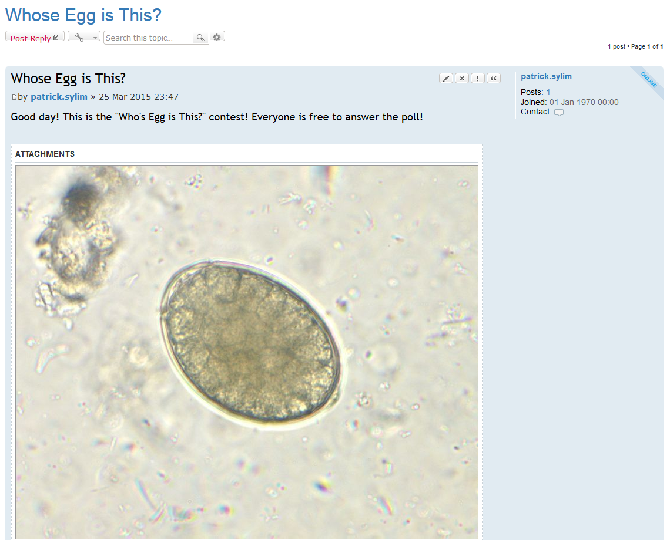
Figure 25. Topic with an attachment. Note the Post Reply button on the upper left.

Posting and deleting a reply are similar to posting and deleting a topic, respectively.

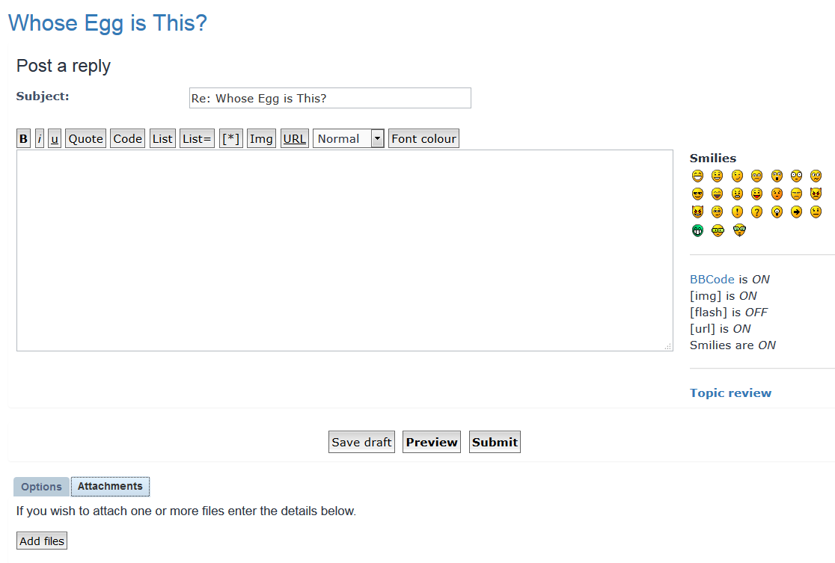
Figure 26. Post reply screen. You may also upload attachments to a reply.

To delete a reply, look for the [x] button on the reply itself.

Now you are equipped with the knowledge to take advantage of the functions the MTP system has to offer. Congratulations! We hope you can use the system to assist you in providing the best service to your patients! Thank you for your support!

